“I die the King’s faithful servant.
But God’s first.”

St Thomas More (1478-1535)
Scholar, Linguist, Councillor to King Henry VIII,
Lord High Chancellor of England, Saint

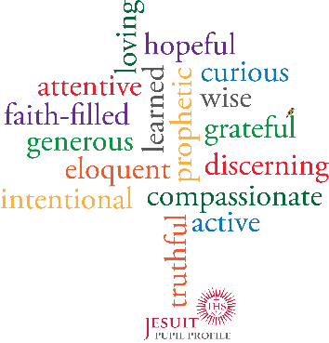
Pupils in a Jesuit school are growing to be faith-filled in their beliefs and hopeful for the future.

Jesuit schools help their pupils grow by passing on the living and faith-filled tradition of Jesus Christ; by having persevering faith in their pupils, and by encouraging them, in turn, to have faith and hope in others.

